***AWS PROJECT-2***

***Project title:- AWS EC2 Instance Automation with Lambda and CloudWatch, SNS.***

**Project Description*:***

We have a requirement to automate the start and stop of an Amazon EC2 instance on a daily basis. This automation will help us reduce costs and ensure that the EC2 instance is only running during the required hours. We will achieve this by leveraging AWS Lambda for the execution and AWS CloudWatch Events for scheduling.

**Project Objectives:**

* Automatically start an Amazon EC2 instance at 9:00 AM daily.

* Automatically stop the same EC2 instance at 6:00 PM daily.

Submitted by – Ambadi Akshaya

Gmail – akshayaambadi3@gmail.com

**Launch an EC2 Instance**

1. Go to EC2 dashboard.
2. Click on Launch Instance
3. Give a name to the Instance, I have given “pro-2”.
4. Give the Quick sort as Amazon linux or ubantu here ,I have given as Amazon Linux
5. Select instance type as “t2-micro”,for cost optimization.
6. Give a Key-pair which you have already created.
7. In the Network Settings, Give the default VPC and Enable the auto assign ip address.
8. Select the security groups.
9. Click on Launch Instance at the bottom.

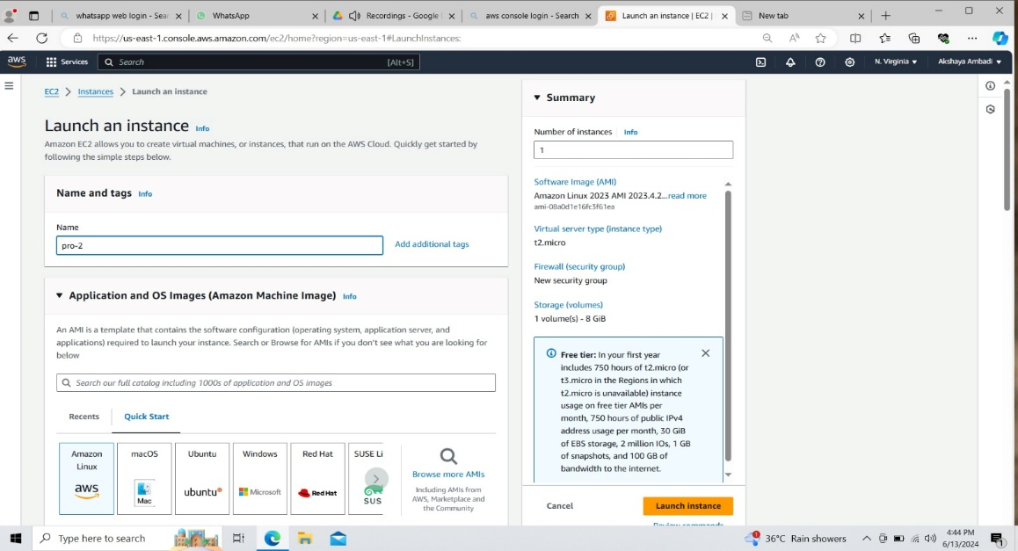

**Create an IAM policy**

1. Search IAM.
2. Select ‘policies’ from the dashboard and then click on it.

Create the policy.

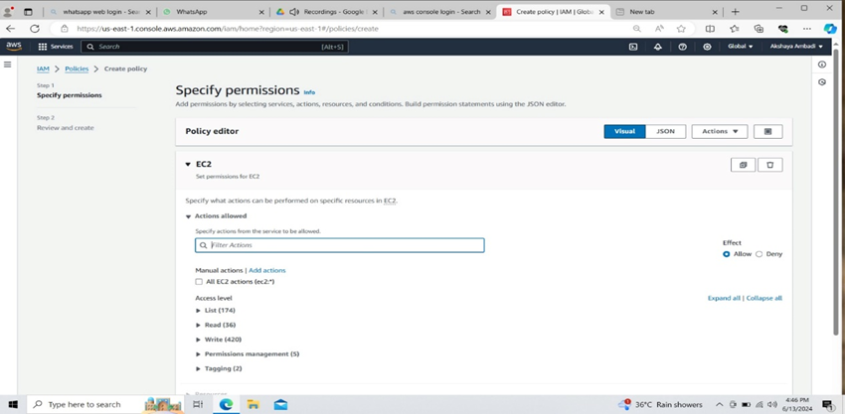

1. Search ‘EC2’ in the service box and then select it as a service.
2. Give ‘Start instances’ and ‘Stop instances’ as actions.
3. For Resource region give any region.
4. Copy the instance ID and paste it in the resource instance from the instance
5. Click on ‘Add ARNs’
6. Click on ‘Next’ button.

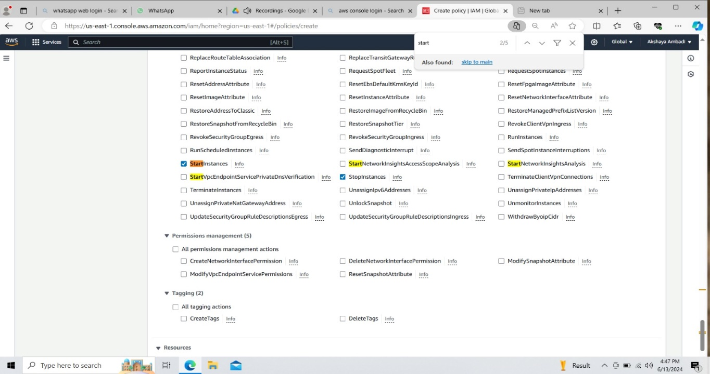

1. Give a policy name and click on create policy.

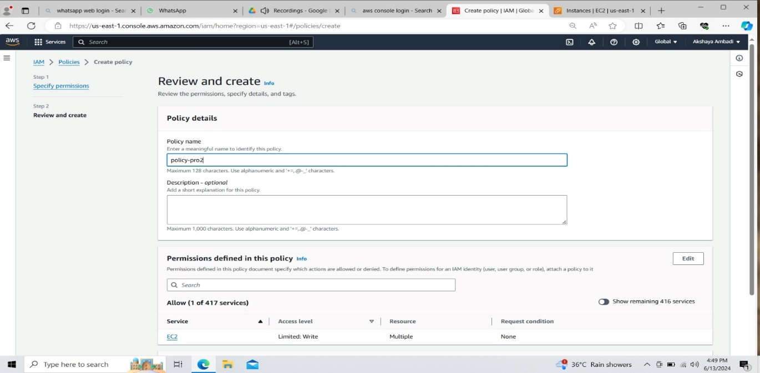

**Create an IAM Role**

1. Go to Roles.
2. Select AWS Service as trusted entity
3. Select use case as Lambda.
4. Click on next.

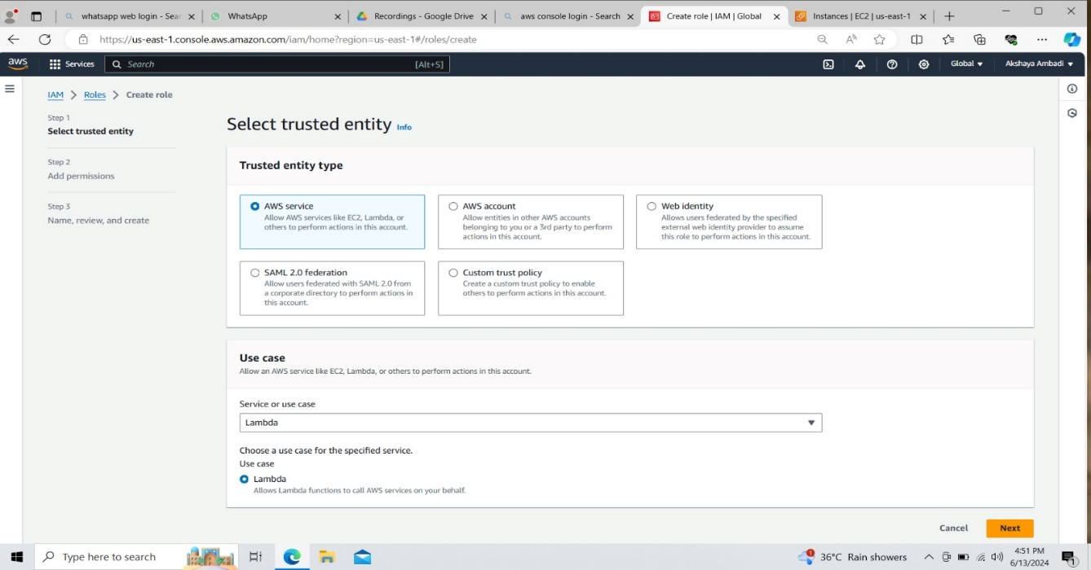

1. In Add Permissions, give the policy name you have created. 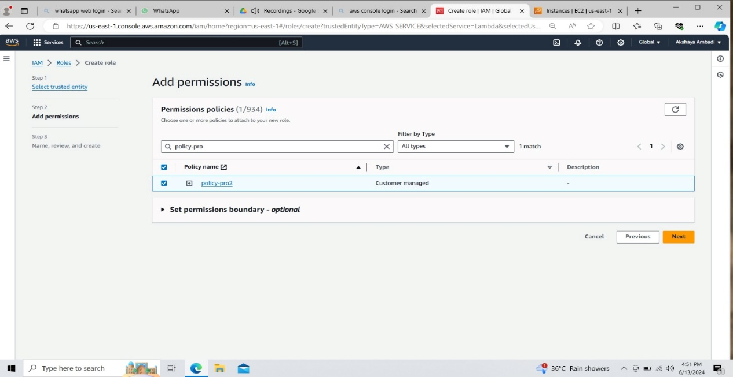
2. Give a name and create the role.

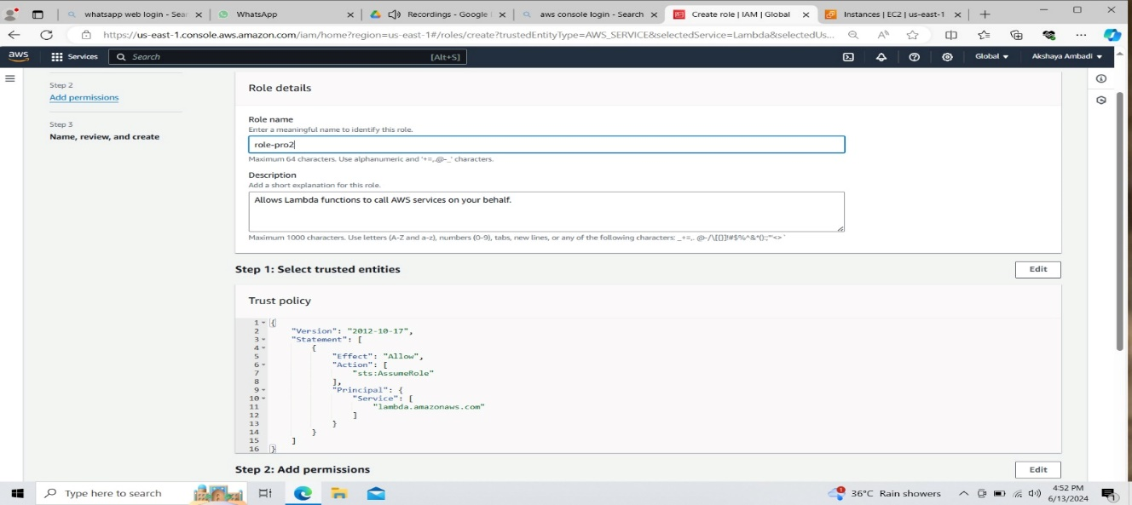

**Create 2 Lambda funtions to start and stop instance**

1. Navigate to AWS Lambda and click on create Function.

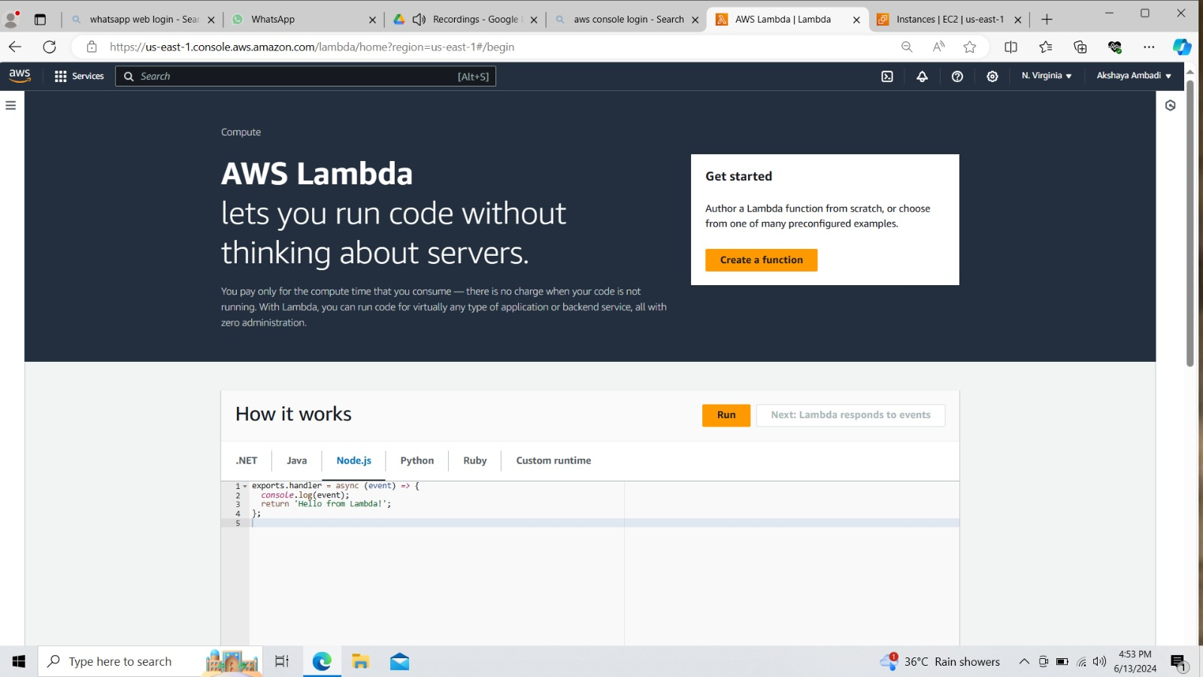

1. Give the basic information such as name and give runtime as ‘Python’.
2. Click on ‘change default execution’ role and select the existing role.
3. Click on create Function.

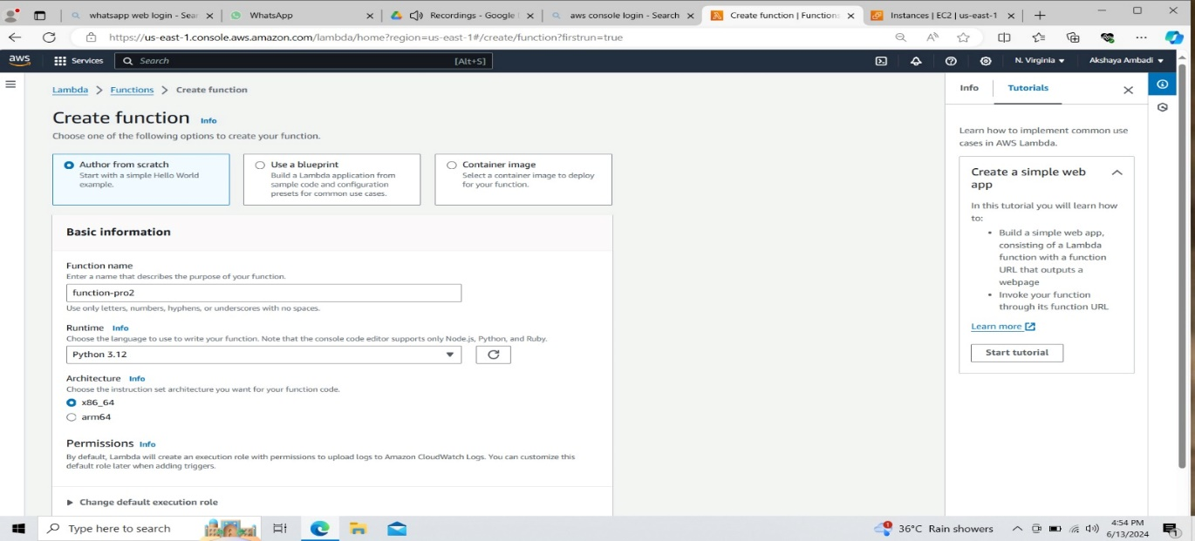

1. Give the python code for start instance and change region and instance ID.

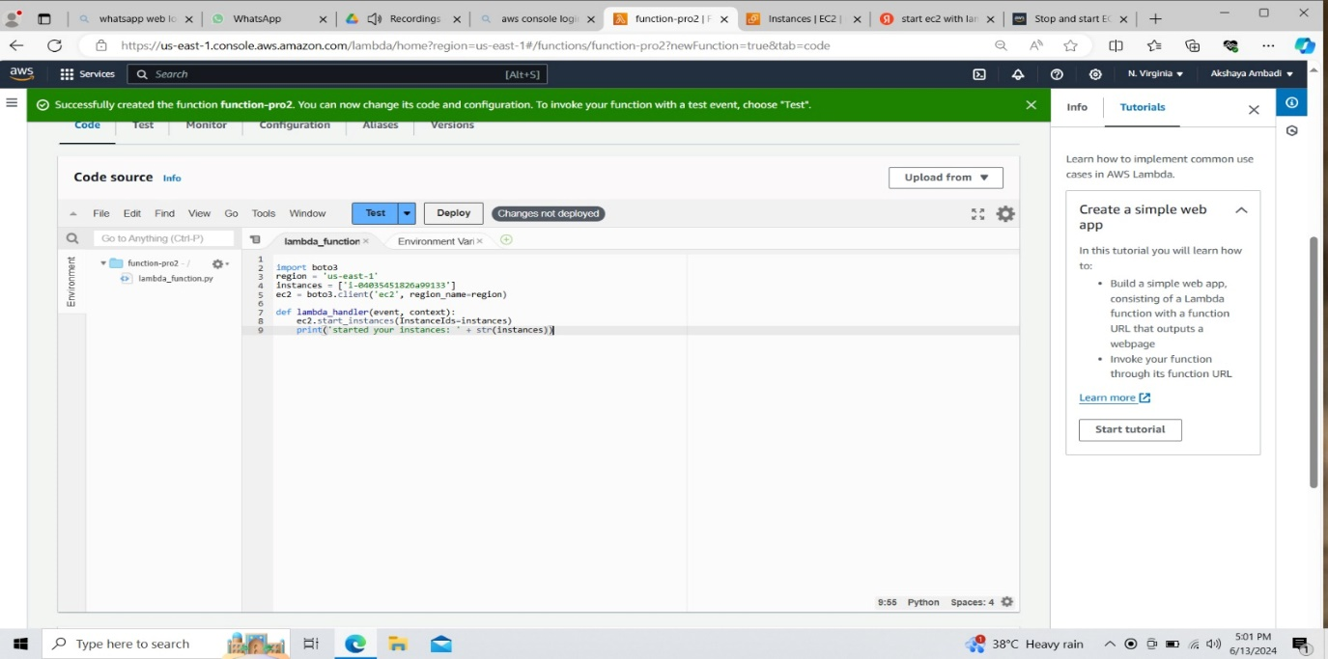

1. For sample testing, stop the instance and deploy the code.
2. Click on test and the instance should be running.

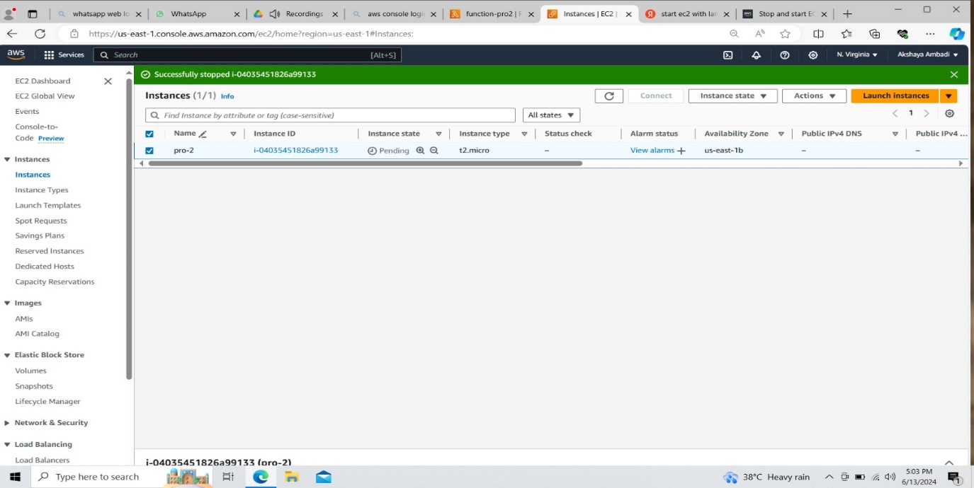

1. For stop instance create another lambda function and follow the same steps which were used in creating start instance and replace the code with stop instance python code.

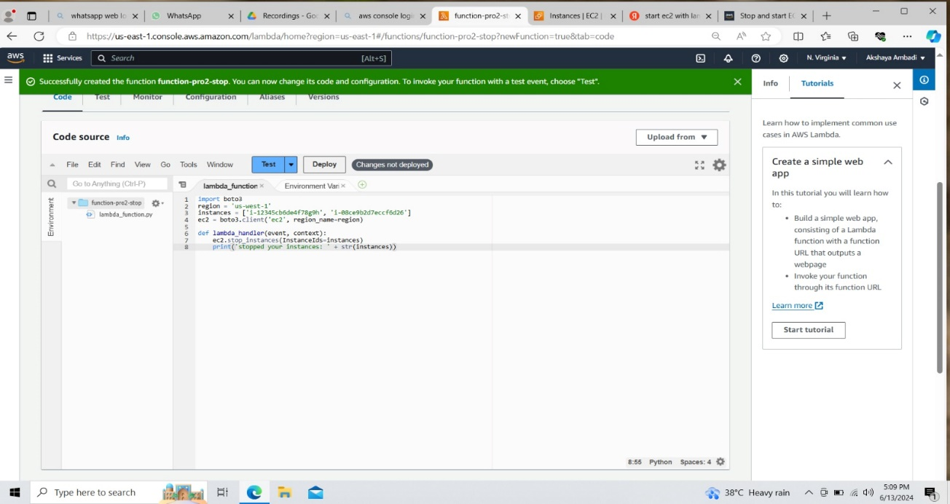

1. Here, after testing the code the instance needs to get stopped.

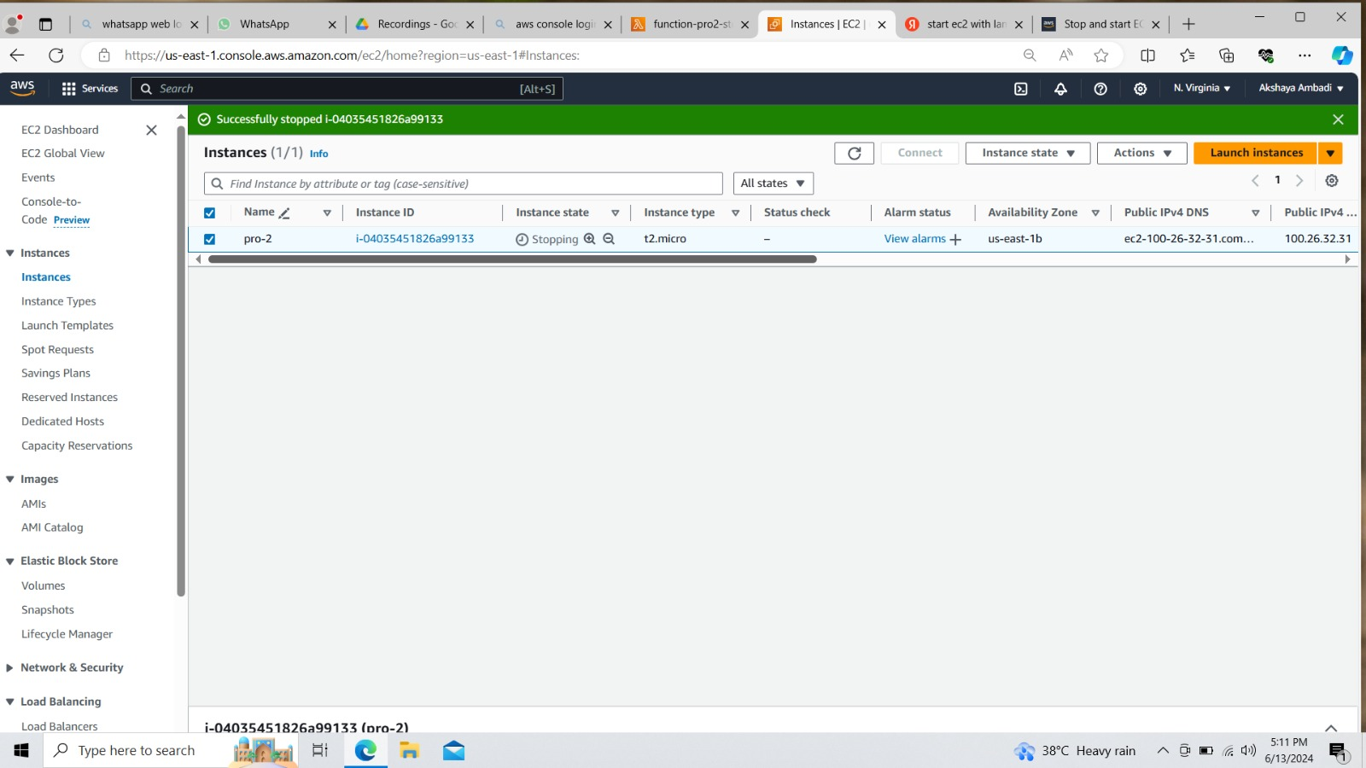

**Create schedules in cloudwatch**

1. Go to cloudwatch and create role.

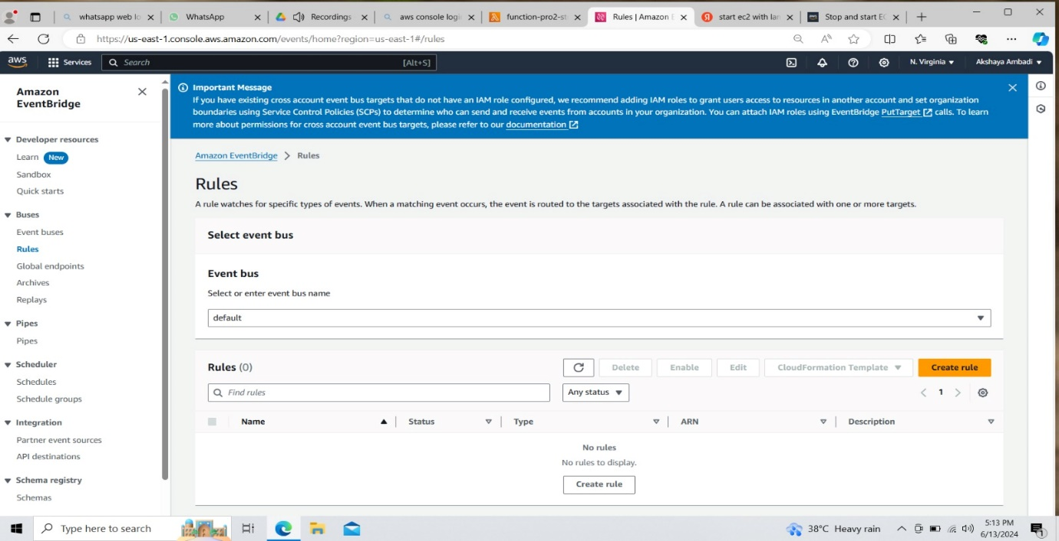

2. Give the basic information and click on ‘Continue in EventBridge Scheduler’.

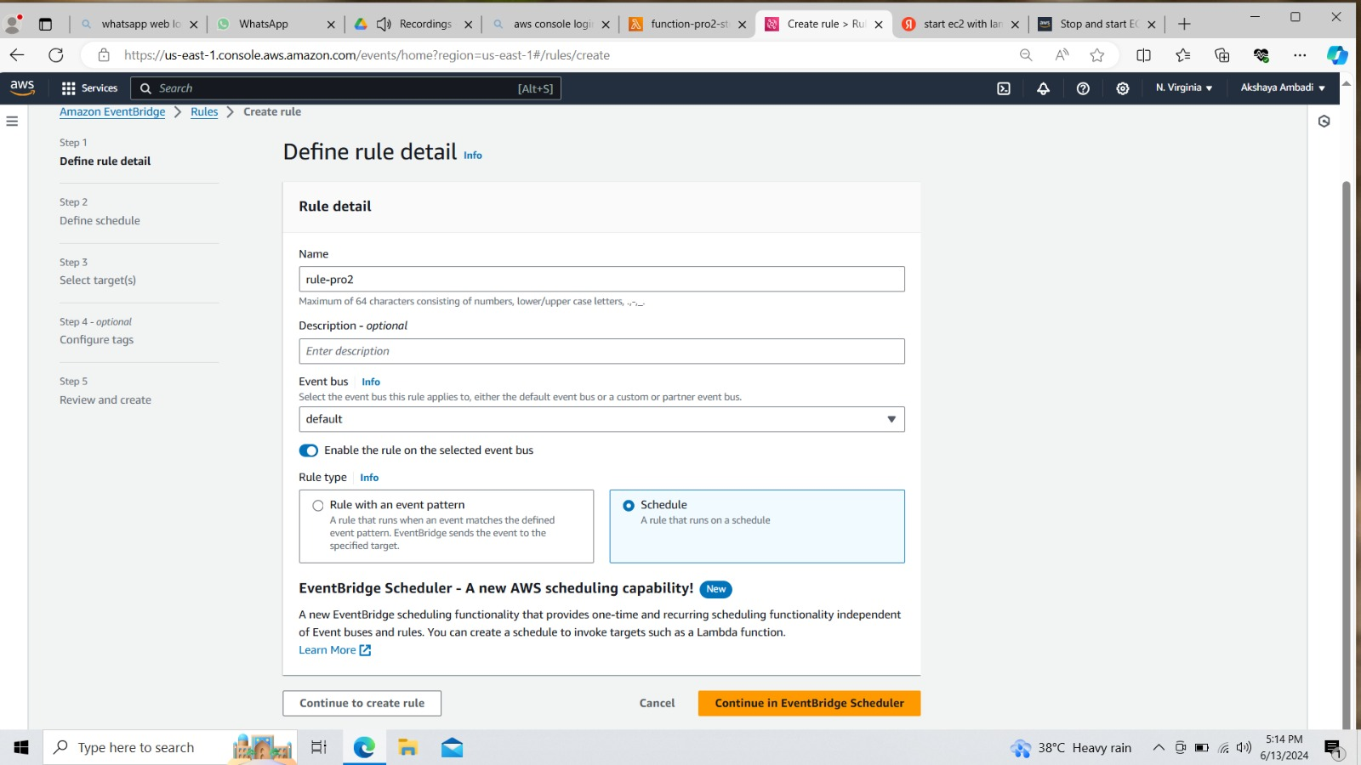

1. Specify schedule details like name and description.
2. Select Recurring Schedule and use cron-based schedule model.

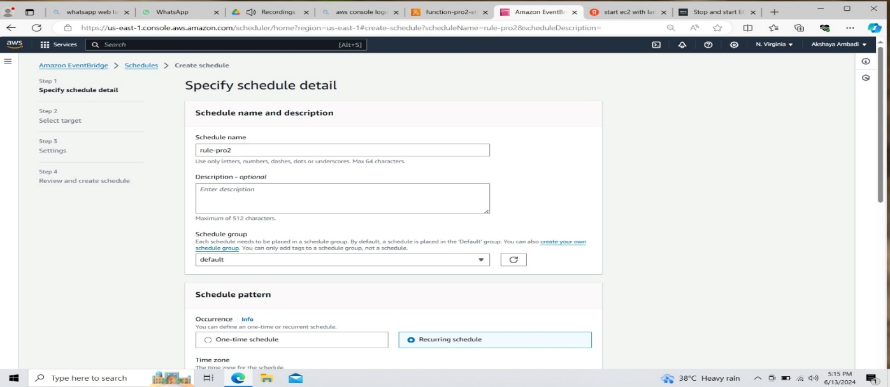

1. As per the project, the instance needs to get start at 9am and stop at 6pm automatically.
2. So give the scheduling for start instance and click on next.

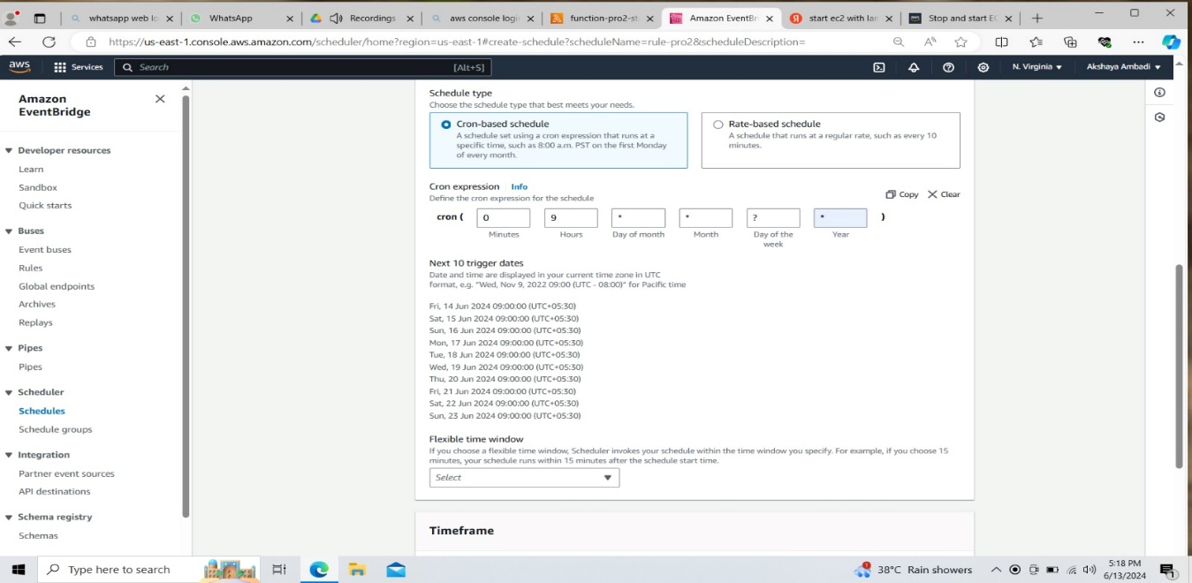

1. Give Target API as ‘AWS Lambda’.

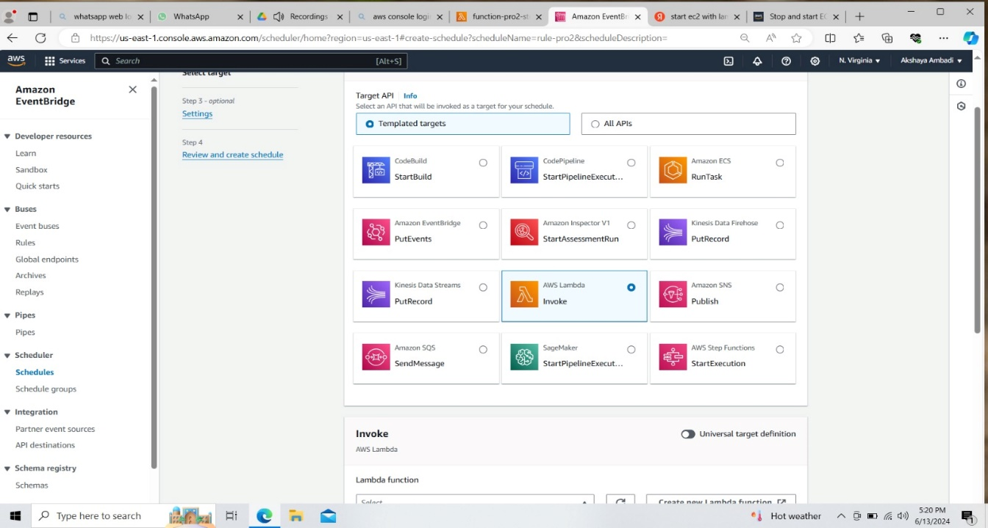

1. Review and create schedule.

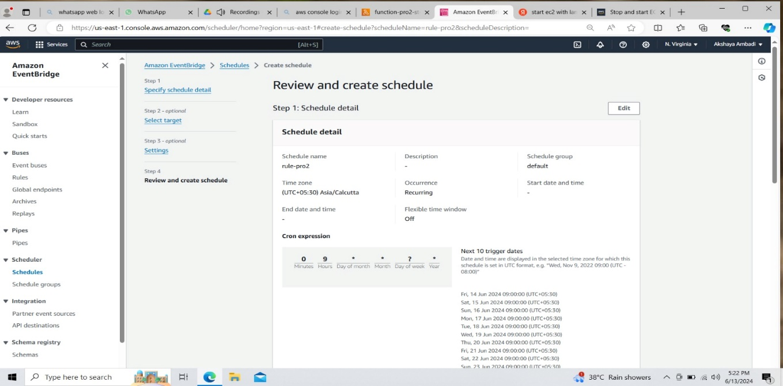

1. Now create another Schedule in the same way for stop instance.
2. Change the schedule time for stop instance.

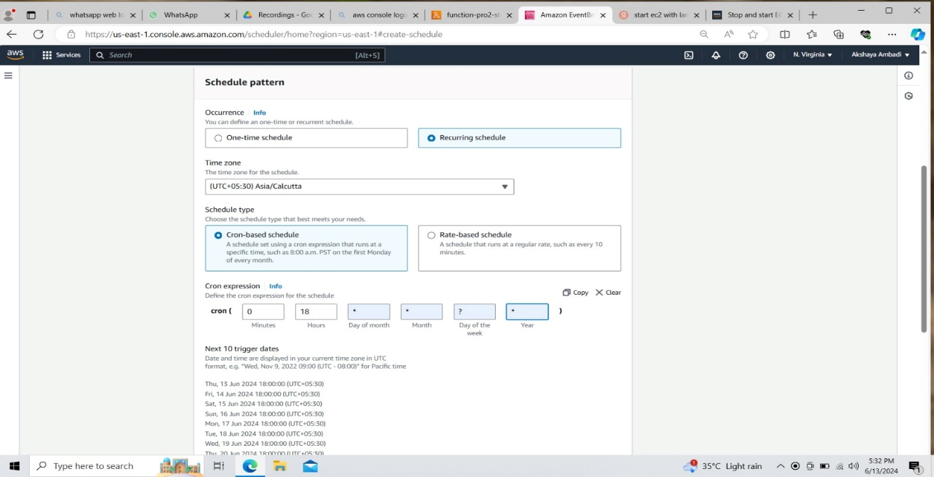

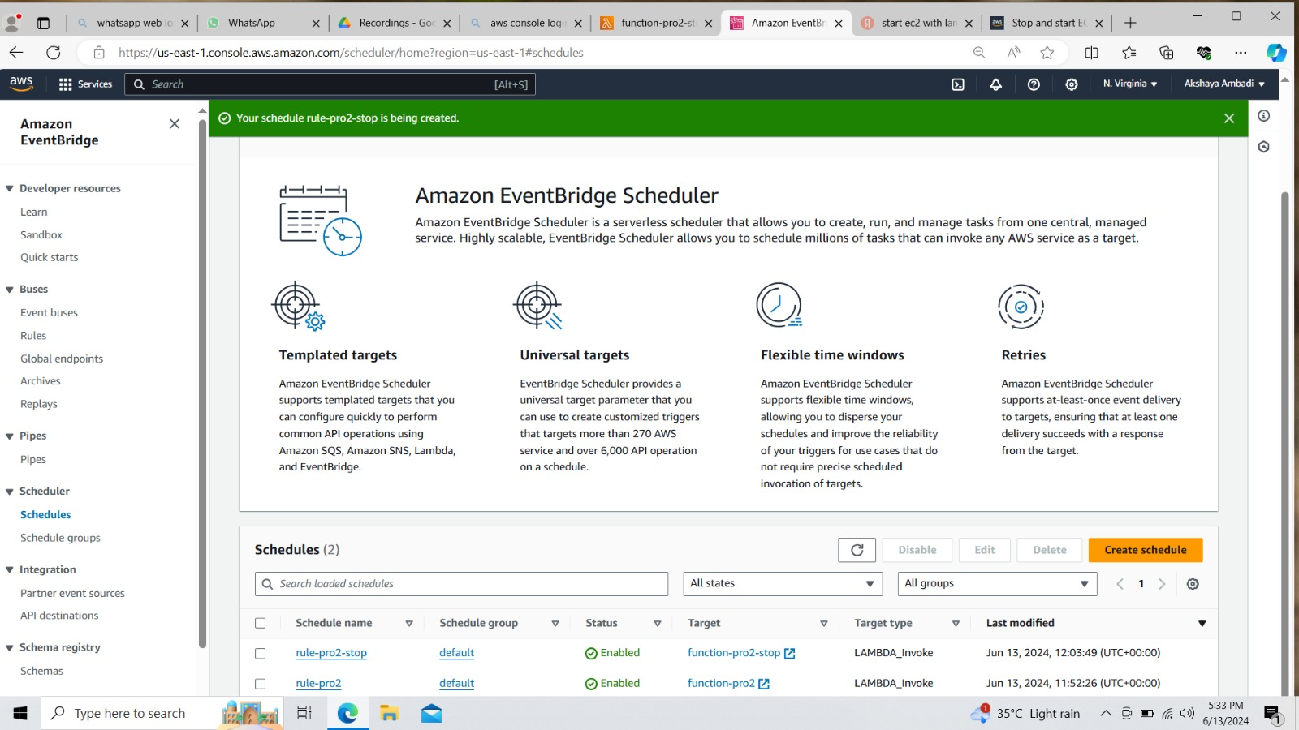

**Create a Rule in cloudWatch and attach SNS**

1. Click on create role and give the basic information.
2. Select ‘Rule with an event pattern’ and click on create rule.
3. In the event pattern, choose ‘EC2’ as the service, and then select ‘EC2 Instance State change Notification’ as event type.

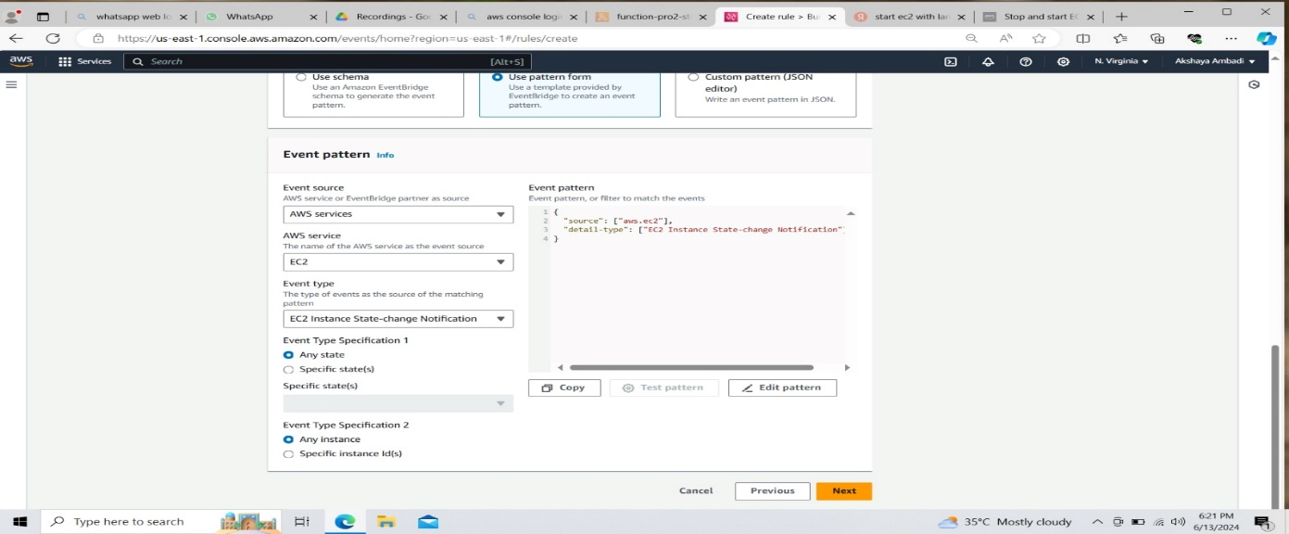

1. Review and create role.

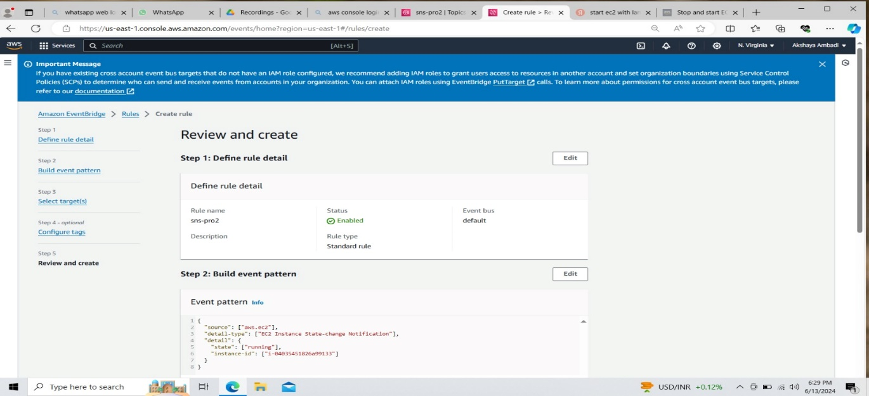5. Now create SNS and attach it to the role.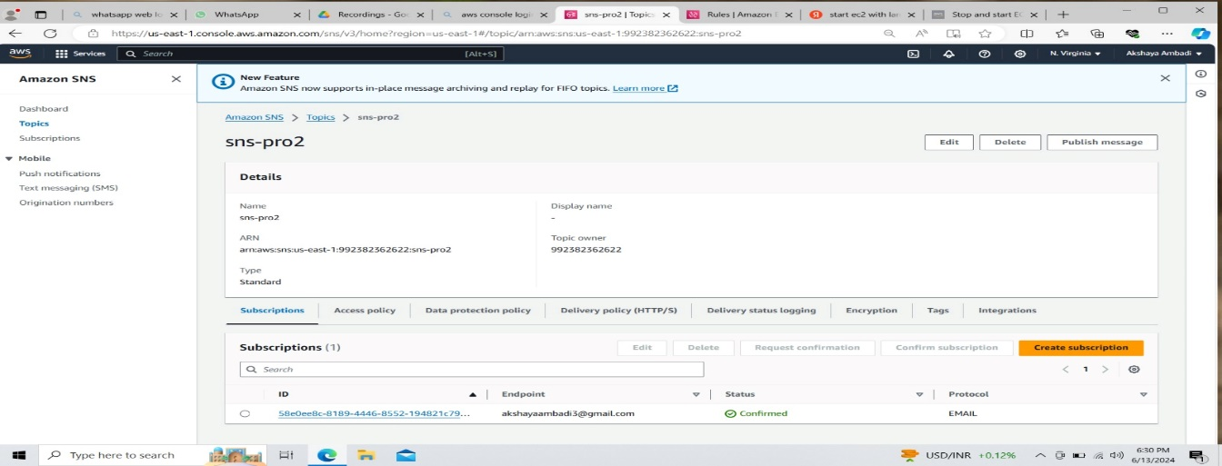

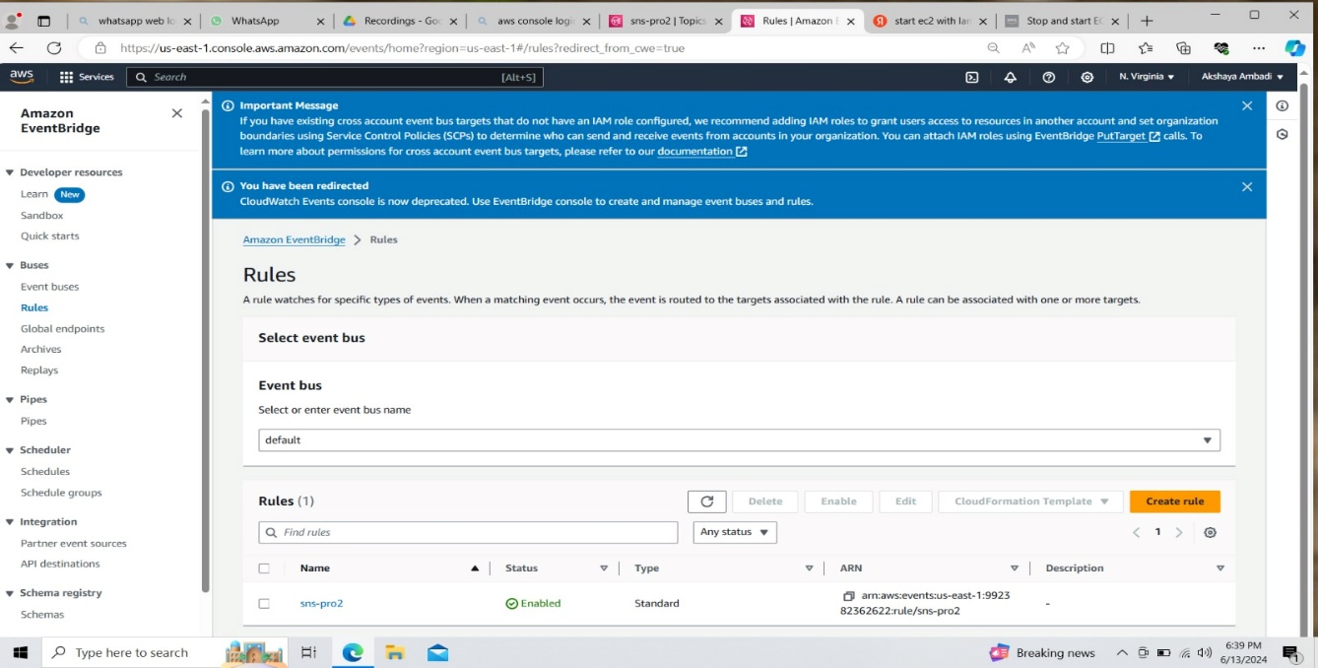

Now if we change the instance state then we will get a notification mail.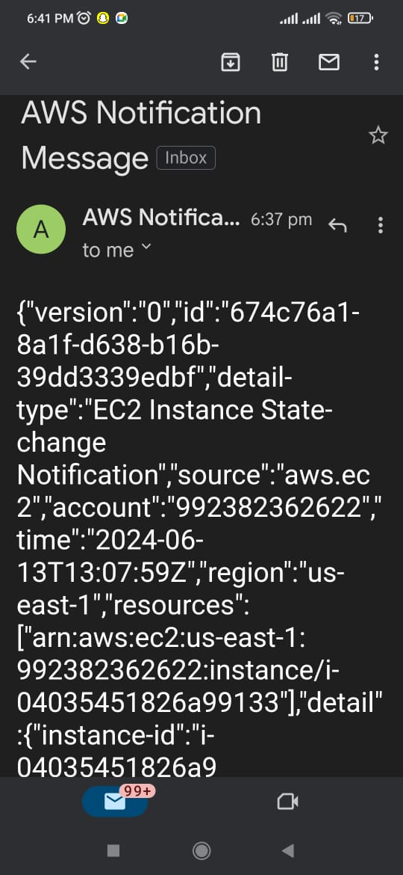

As per the given time, the instance started automatically at 9 am.

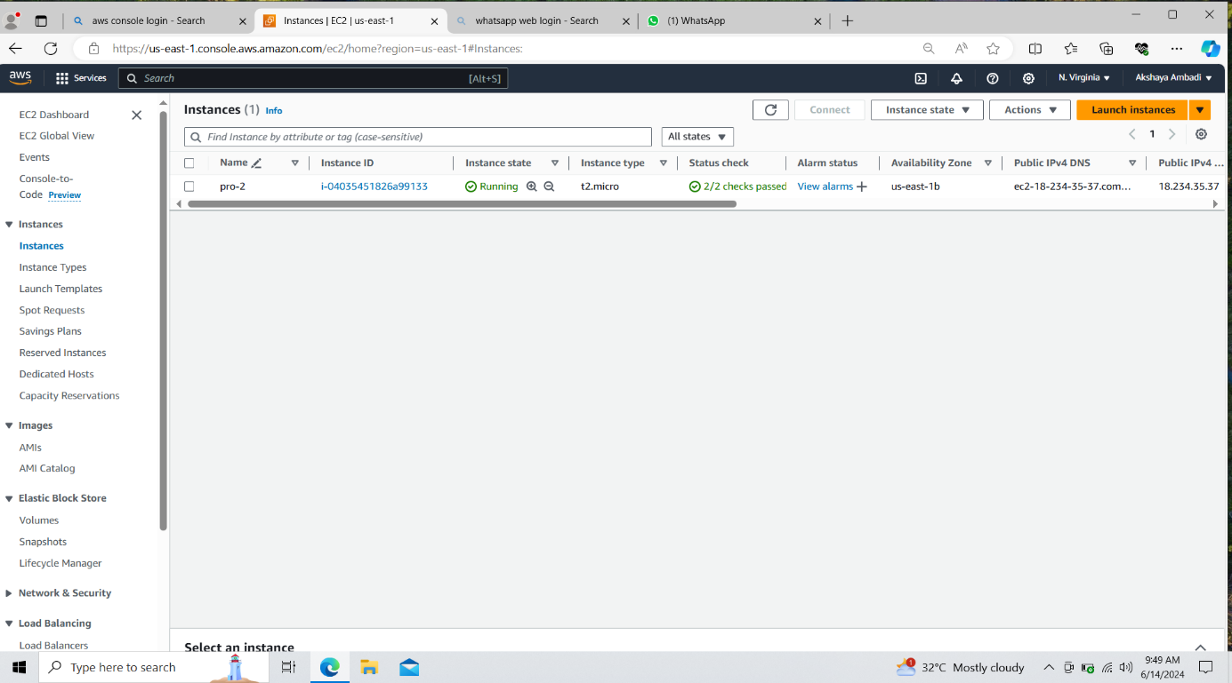

And it got stopped at 6 pm.